**DIGITAL NURTURE 4.0 DEEP SKILLING JAVA FSE-WEEK1**

**NAME: SIVITHA GUNASEKARAN**

**SUPERSET ID: 6413354**

**WEEK 1: DESIGN PATTERNS AND PRINCIPLES**

**TASK 2:**

**Implementing the Factory Method Pattern**

**Scenario:**

You are developing a document management system that needs to create different types of documents (e.g., Word, PDF, Excel). Use the Factory Method Pattern to achieve this.

**Steps:**

1. **Create a New Java Project:**
   * Create a new Java project named **FactoryMethodPatternExample**.
2. **Define Document Classes:**
   * Create interfaces or abstract classes for different document types such as **WordDocument**, **PdfDocument**, and **ExcelDocument**.
3. **Create Concrete Document Classes:**
   * Implement concrete classes for each document type that implements or extends the above interfaces or abstract classes.
4. **Implement the Factory Method:**
   * Create an abstract class **DocumentFactory** with a method **createDocument()**.
   * Create concrete factory classes for each document type that extends DocumentFactory and implements the **createDocument()** method.

**My Codes and Screenshot proof as follows:**

**DocumentFactory.java**

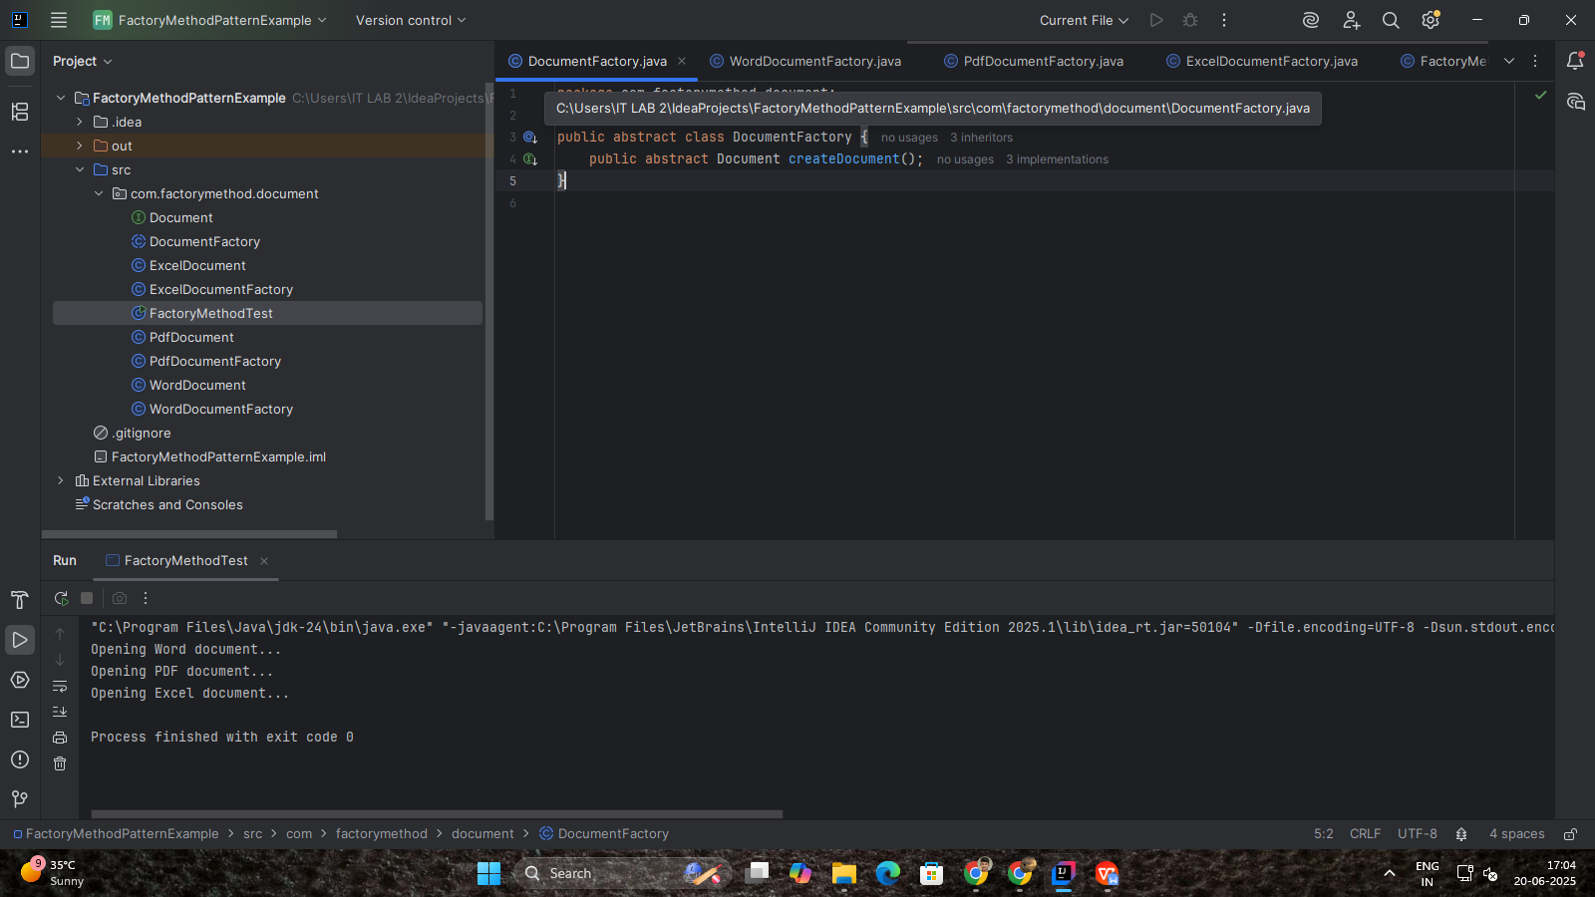

**WordDocumentFactory.java**

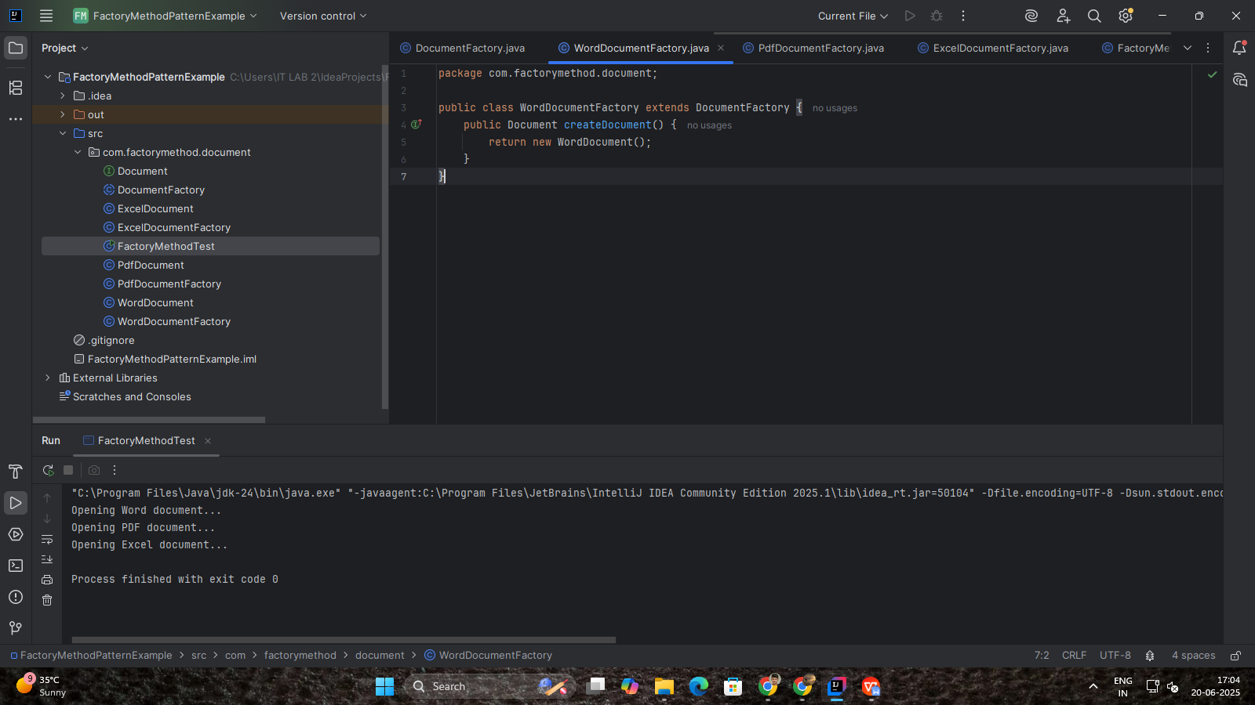

**PdfDocumentFactory.java**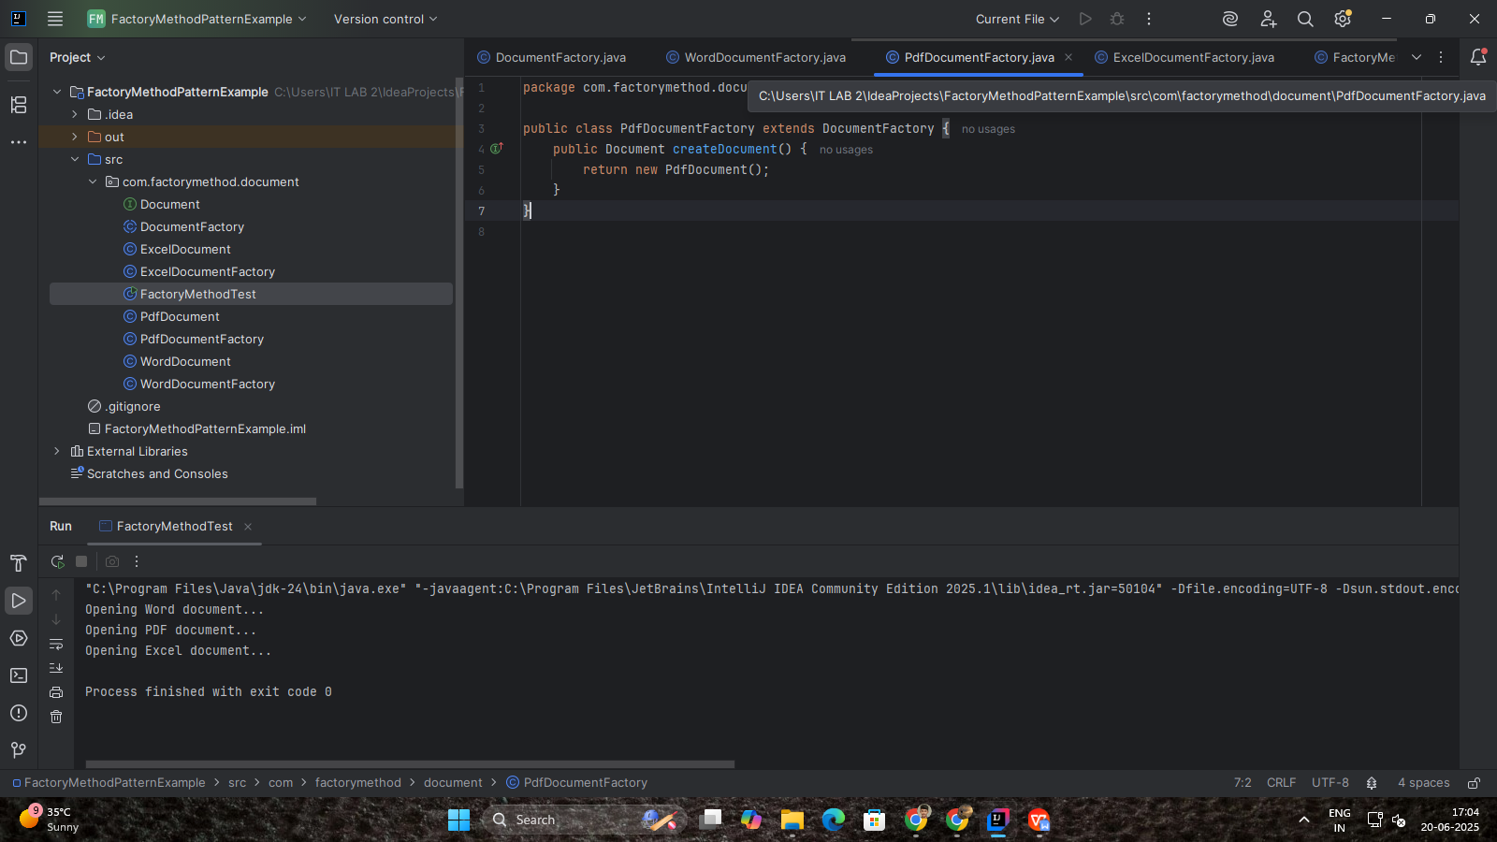

**ExcelDocumentFactory.java**

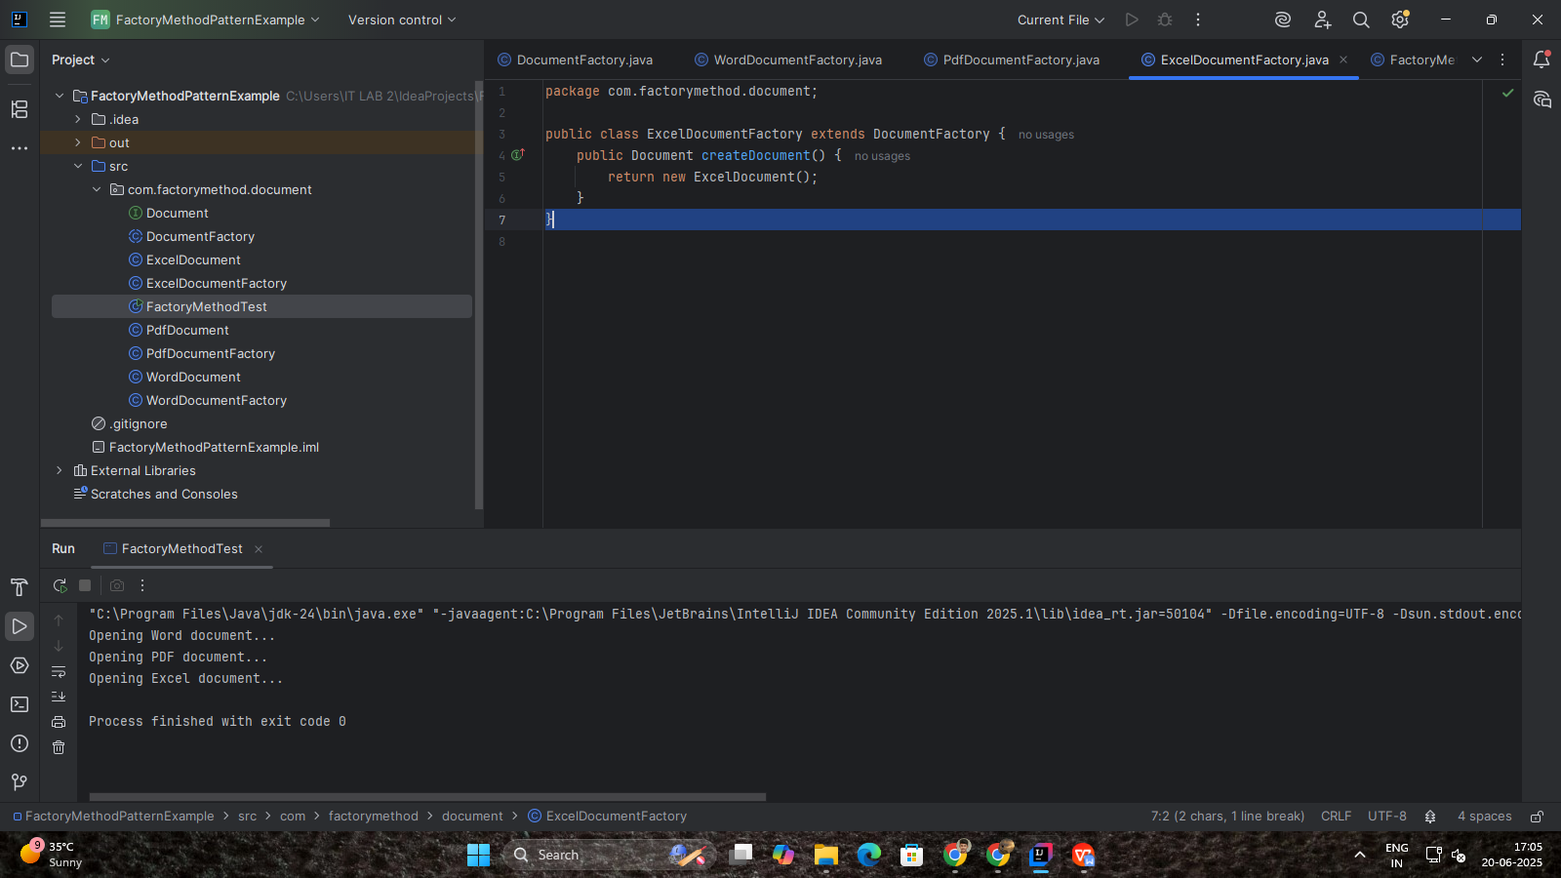

**FactoryMethodTest.java**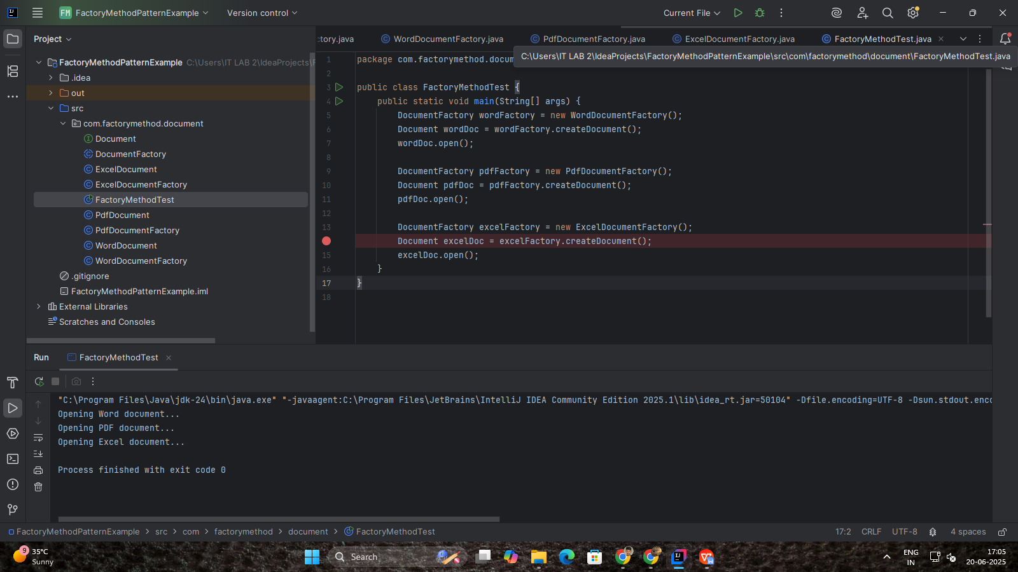

**PdfDocument.java**

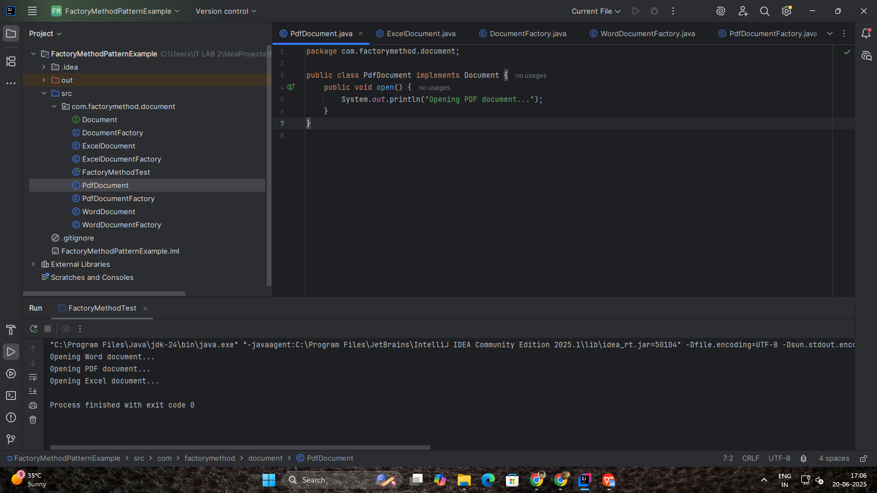

**WordDocument.java**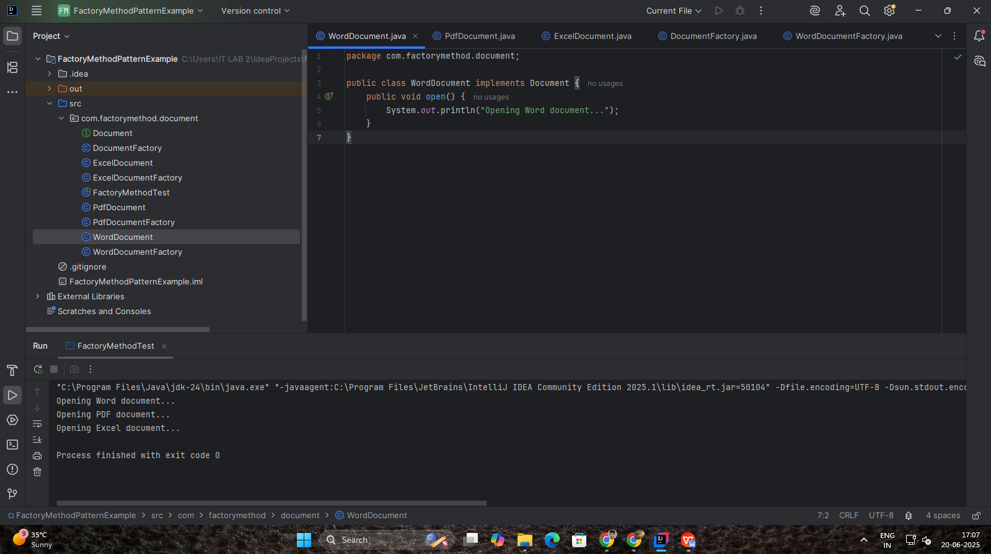

**WordDocumentFactory.java**

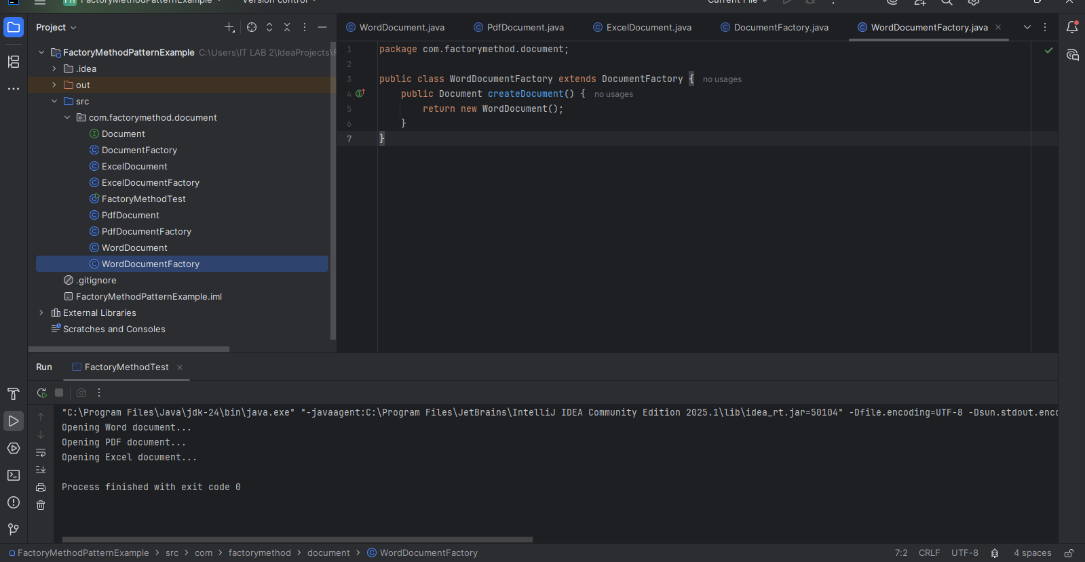

**OUTPUT:**

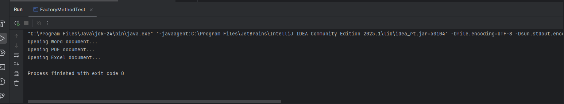

**SAMPLE CODE :**

**File: Document.java**

**-------------------**

package com.factorymethod.document;

public interface Document {

void open();

}

**File: WordDocument.java**

**-----------------------**

package com.factorymethod.document;

public class WordDocument implements Document {

public void open() {

System.out.println("Opening Word document...");

}

}

**File: PdfDocument.java**

**----------------------**

package com.factorymethod.document;

public class PdfDocument implements Document {

public void open() {

System.out.println("Opening PDF document...");

}

}

**File: ExcelDocument.java**

**------------------------**

package com.factorymethod.document;

public class ExcelDocument implements Document {

public void open() {

System.out.println("Opening Excel document...");

}

}

**File: DocumentFactory.java**

**--------------------------**

package com.factorymethod.document;

public abstract class DocumentFactory {

public abstract Document createDocument();

}

**File: WordDocumentFactory.java**

**------------------------------**

package com.factorymethod.document;

public class WordDocumentFactory extends DocumentFactory {

public Document createDocument() {

return new WordDocument();

}

}

**File: PdfDocumentFactory.java**

**-----------------------------**

package com.factorymethod.document;

public class PdfDocumentFactory extends DocumentFactory {

public Document createDocument() {

return new PdfDocument();

}

}

**File: ExcelDocumentFactory.java**

**-------------------------------**

package com.factorymethod.document;

public class ExcelDocumentFactory extends DocumentFactory {

public Document createDocument() {

return new ExcelDocument();

}

}

**File: FactoryMethodTest.java**

**----------------------------**

package com.factorymethod.document;

public class FactoryMethodTest {

public static void main(String[] args) {

DocumentFactory wordFactory = new WordDocumentFactory();

Document wordDoc = wordFactory.createDocument();

wordDoc.open();

DocumentFactory pdfFactory = new PdfDocumentFactory();

Document pdfDoc = pdfFactory.createDocument();

pdfDoc.open();

DocumentFactory excelFactory = new ExcelDocumentFactory();

Document excelDoc = excelFactory.createDocument();

excelDoc.open();

}

}

**Expected Output:**

**----------------**

Opening Word document...

Opening PDF document...

Opening Excel document...